

**ANNA UNIVERSITY**

**Madras Institute of Technology**

**CS6105 – Digital Fundamental of Computer Organisation**

**Department of Computer Technology**

PROJECT REPORT ON

**“PASSWORD SECURITY SYSTEM USING LOGIC GATES”**

Submitted By:-

SIVARANJANI.S – 2022503045

KRITHIGA.H – 2022503511

NEELAVATHY.G – 2022503513

KIRUTHIKA.A-2022503523

**Bonafide Certificate**

This is to certify that the project entitled  **password security system using logic gates** is a bonafide work carried out by the following students of **Madras Institute Of Technology, Anna University**, in partial fulfillment of the requirements for the **Computer Technology** during the academic year **2023-2024**.

**Project Details:**

**PASSWORD SECURITY SYSTEM USING LOGIC GATES**

-  **Course:** Computer Science and Engineering

- **Semester:** 3

**Group Members:**

1. KIRUTHIKA.A-2022503523
2. NEELAVATHY.G-2022503513
3. KRITHIGA.H– 2022503511
4. SIVARANJANI.S-2022503045

**Declaration:**

We hereby declare that the project work presented in this report is our own and has been carried out under the supervision of our project guide. We also affirm that this work has not been submitted elsewhere for any examination or project.

**ACKNOWLEDGEMENT**

We extend our heartfelt gratitude to our project guide, Dr. V.P. Jayachitra whose guidance and support were indispensable throughout the project. Our appreciation also goes to the faculty, staff, and our peers at Madras Institute of Technology, Anna University for their valuable contributions and collaborative spirit. Special thanks to our friends and family for their unwavering support. This project would not have been possible without the combined efforts of everyone mentioned. Thank you.

**Aim:**

The aim of this project is to design and implement a password security system using logic gates to enhance the security of digital systems and applications.

**Objective:**

* Implement the system using logic gates to ensure a hardware-based security approach.
* Enhance the overall security of digital systems and applications using this circuit as a model.
* Explain the system with circuit diagram and truth table and to satisfy all the input requirements.

**COMPONENTS REQUIRED** :

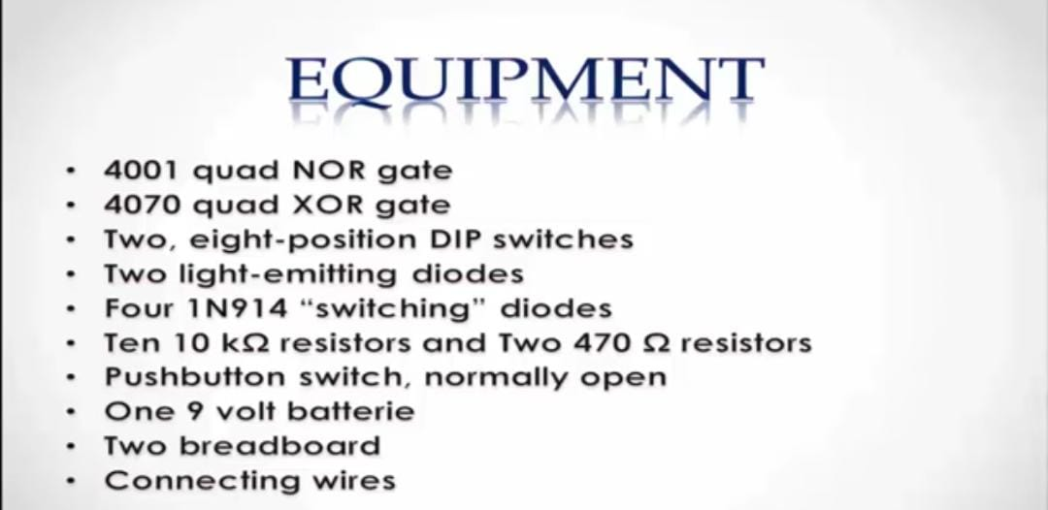

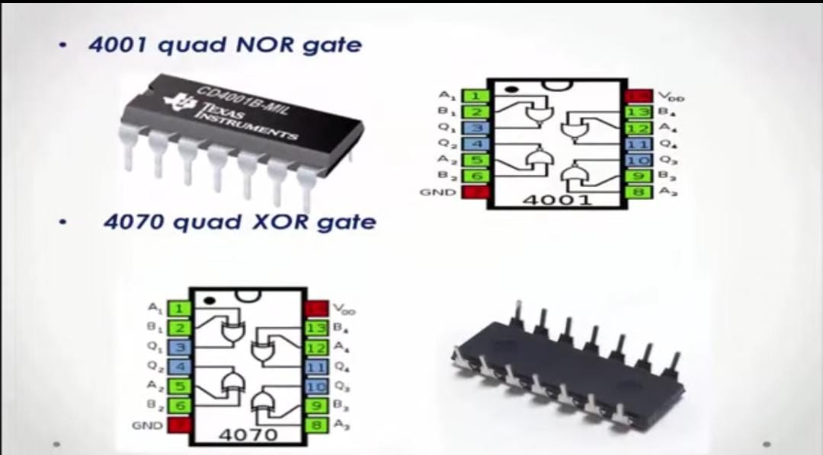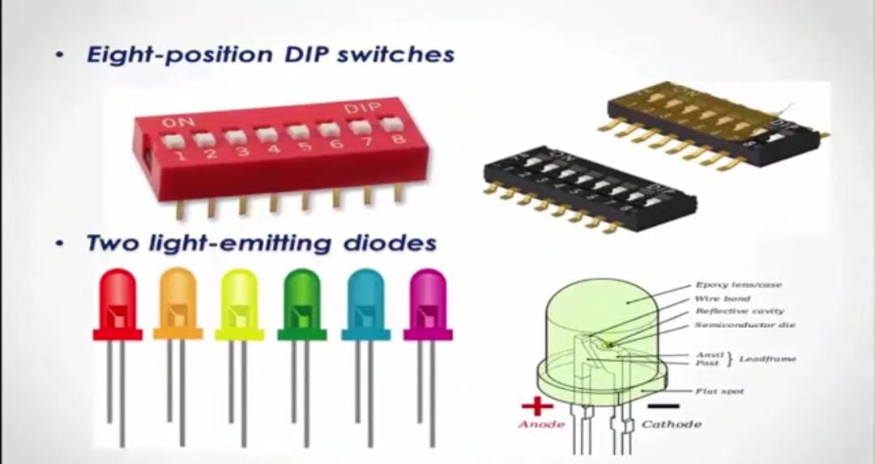

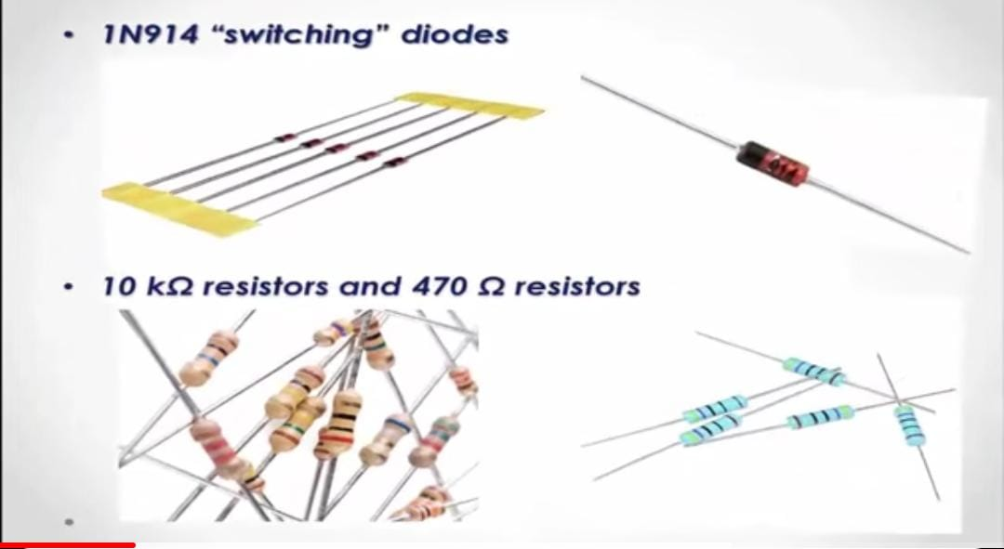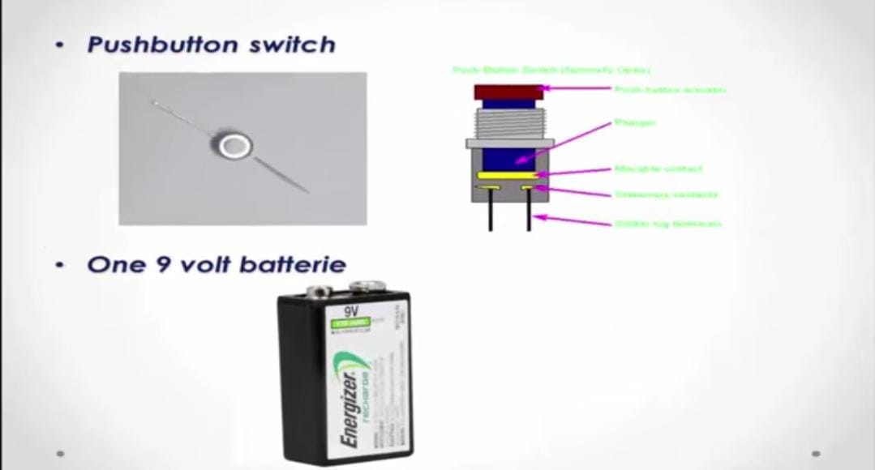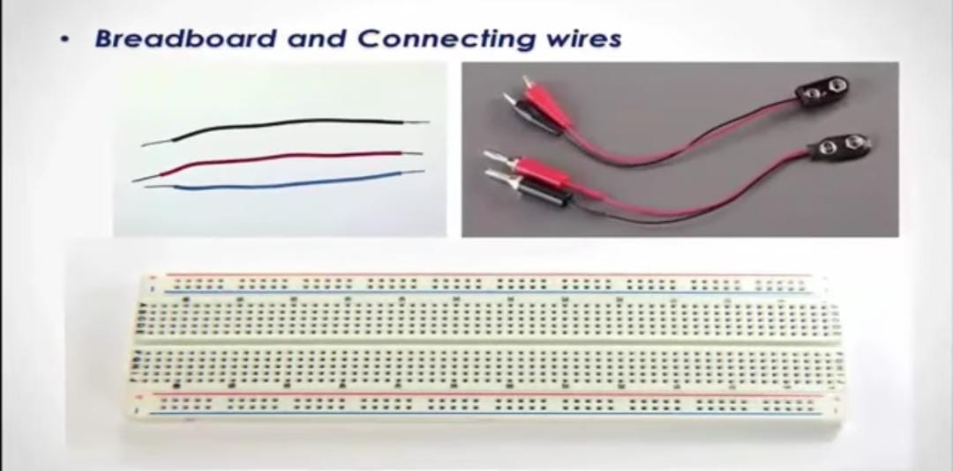

**CIRCUIT DIAGRAM** :

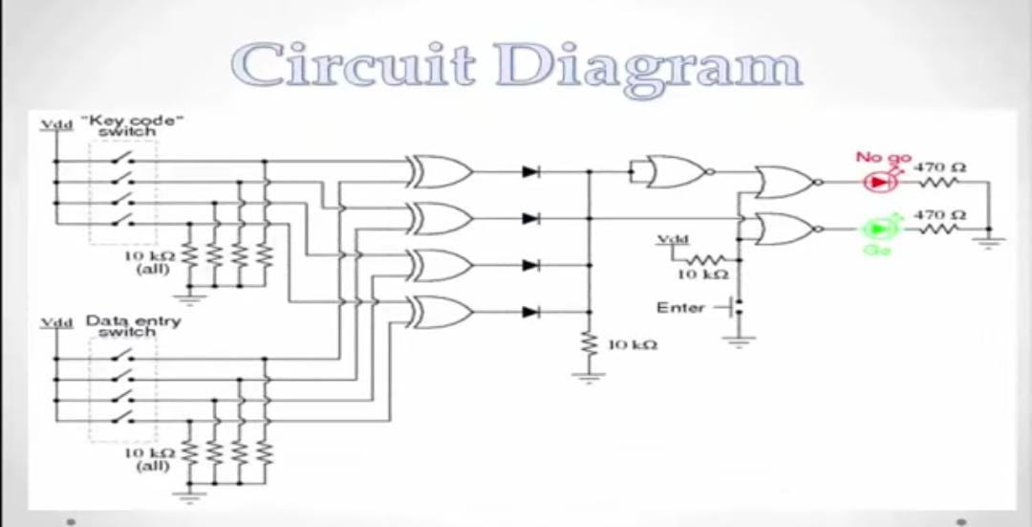

**METHODOLOGY :**

A password security system using logic gates works by allowing a user to set a password using the first four inputs. A separate set of four inputs is then used by another user to try to predict the passcode. If the code matches the initial one, a HIGH output is given.

The output terminals of the four XOR gates are connected through a diode network that functions as a four-input OR gate. If any of the four XOR gates outputs a “high” signal, this indicates that the entered code and the key code are not identical. A “high” signal is then passed on to the NOR gate logic.

**TRUTH TABLE** :

HIGH = 1

LOW=0

|  |  |  |  |  |  |  |  |  |
| --- | --- | --- | --- | --- | --- | --- | --- | --- |
| I0 | I1 | I2 | I3 | O0 | O1 | O2 | O3 | LED |
| 0 | 1 | 1 | 0 | 0 | 1 | 1 | 0 | HIGH |
| 1 | 0 | 0 | 1 | 1 | 1 | 0 | 1 | LOW |
| 0 | 0 | 1 | 1 | 0 | 0 | 1 | 1 | HIGH |
| 0 | 1 | 1 | 0 | 1 | 0 | 0 | 1 | LOW |
| 1 | 1 | 1 | 1 | 1 | 1 | 1 | 0 | HIGH |
| 1 | 0 | 1 | 0 | 1 | 0 | 1 | 0 | HIGH |
| 0 | 0 | 0 | 1 | 0 | 0 | 1 | 0 | LOW |

Here the i0 ,I1,i2,i3 represent the initial passcode we set and o0,o1,o2,o3 represent the passcode we enter to check for access.

HIGH denotes the green led signal and LOW denotes the red led signal.

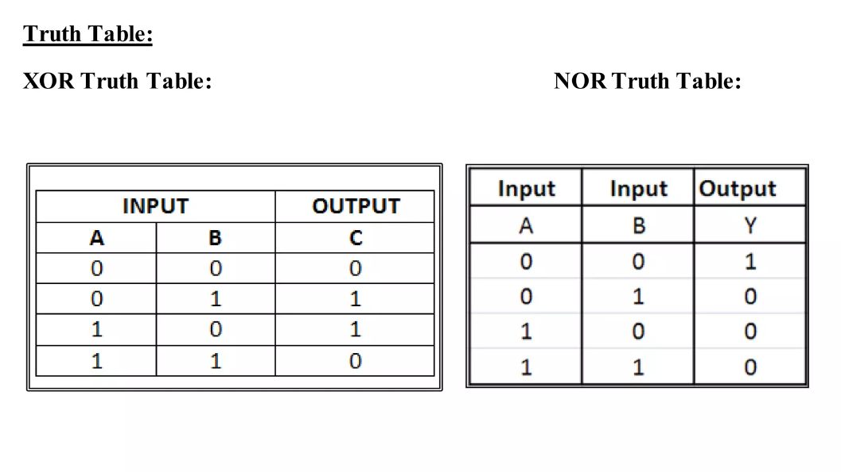

**PROCEDURE :**

a.Set the power supply to 9 volts, and place voltage and ground to the breadboard.

b. Connect voltage to each “key code” switch and each “data entry switch.”

c. Connect a “key code” switch to pins 1, 4, 10, and 13 of the XOR gate, as well as,

connect a “data entry switch” to pins 2, 5, 9, and 12 of the XOR gate.

d. Connect a 10kΩ resistors to each “key code” switch, as well as, to each “data

entry” switch.

e. Place a wire from each resistor to ground.

f. Allow a wire to come from pin 3, pin 6, pin 8, and pin 11 the XOR gate to pins 1,

3, 5, and 9 of the 1N914 “switching” diode.

g. Place a wire from pins 2, 4, 6, and 8 of the 1N914 “switching” diode to a 10kΩ

resistor.

h. Place a wire from the 10kΩ resistors to ground.

i. Connect the pin 2 of the 1N914 “switching” diode to pin 1 of the NOR gate, as

well as, a 10kΩ resistors connected to pin 2 of the 4001 quad.

j. Place a wire from pin 3 of the 4001 quad to pin 4 of the 4001 quad and place a

wire from pin 5 to the pushbutton switch.

k. Connect the pushbutton switch to ground.

l. Place a wire from pin 6 to a light-emitting diode

**Implementation of the Project :**

When the “key code switch” entry doesn’t matches the “data switch entry “ :

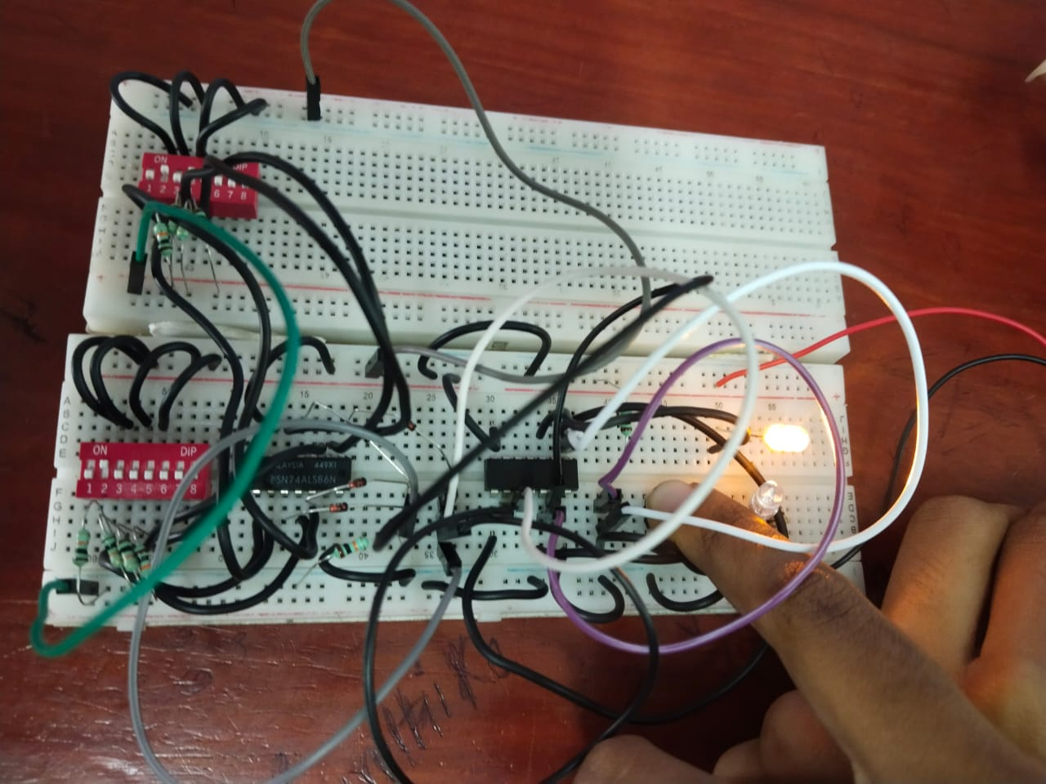

When the “key code switch” entry matches the “data switch entry “ :

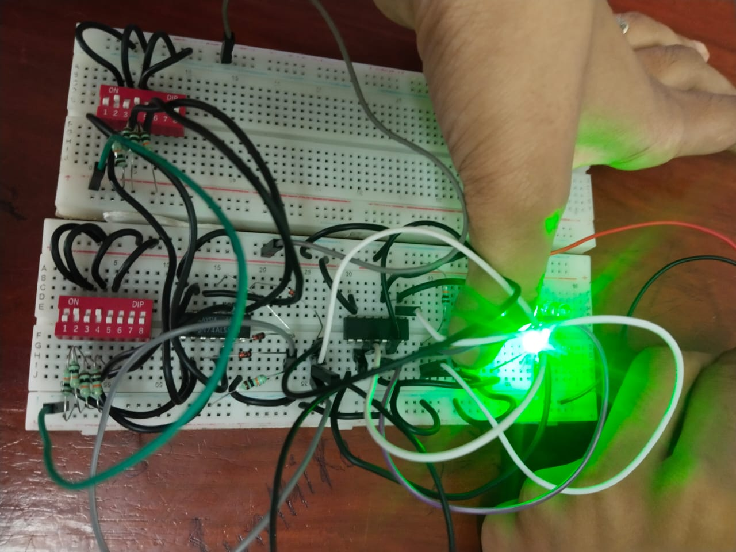

**Related to Industry**

The use of logic gates is critical to industries worldwide. In today’s world,

copious individuals’ input password into his/her security system to secure or to

unsecure his/her home and/or business. A company like Ring provides a great number

of homes with security systems so that individuals can protect his/her property. For

example, individuals can receive alerts and video footage when someone is new

his/her home. Individuals can also check the Ring app at all times to make sure there

is not anything going on in or outside of his/her property. Above it all, a company like

Ring is great with providing security systems to people’s homes thanks to the use of

logic gates within each security system.

The project's success opens doors to various applications, from securing personal devices to implementing access control systems in critical infrastructures. The combination of XOR and NOR gates not only fortifies the security aspect but also contributes to the elegance and simplicity of the overall system.

**CONCLUSION :**

As we conclude this project, it is imperative to acknowledge the potential for future enhancements. Exploring additional cryptographic techniques and incorporating biometric authentication could further fortify the system against evolving security threats.

In essence, the Password Security System project has not only met its objectives but has also laid the groundwork for future developments in secure digital authentication. Through the strategic utilization of XOR and NOR gates, we have demonstrated the efficacy of hardware-based security, paving the way for advancements in safeguarding digital systems and ensuring user privacy in an increasingly interconnected world.